**Structure of the Website**

**Domain name :** Paraty-Origens.com

**2 pages :**

Headers : Organization - Our offer -Contact Us

* The company
  + Organization covers (what (our Mission) – where -How- Who) - our contact should be at the bottom of every page
* The land we offer compliant access to
  + Our offer

Pages in :

Portugues – English

Contents :

The company references (address and reference number - status)

<https://www.facebook.com/profile.php?id=100089674024348>

Whatsapp number for the company

Not yet available

Email address for contact

Contato@paraty-origens.com

Instagram:

@paratyorigens

Videos:

I have the videos but I have difficulties uploading them on Youtube.

<https://drive.google.com/drive/folders/1LgHrCO9S7xxXf6HeBmovWM6G4NJ07U_X?usp=share_link>

**Written contents (in English)**

**Our Mission**

**Accompaniment of the socio-economic development of protected regions with unique characteristics through:**

* The regeneration, the preservation and the promotion of the natural heritage
* The implementation of structured and self-sustainable socio-economic actions to strengthen region’s socio-cultural balance as a barrier to non-organic growth which is a consequence of financial predation
* Development of control strategies to control the growing real estate and financial pressure.

**Where:**

**Cairuçu Environmental Protection Area**

Our place of action is named **Cairuçu.** The area is defined as a federal unit of preservation and sustainable use. This area is classified as an area of Environmental Protection (Area de Proteçao Ambiental – APA); one of the seven types of units of preservation and sustainable use, along with the areas of relevant ecological interest; the national forests; the extractive reserves; the fauna reserve; the sustainable development reserves; and the Private Natural Heritage Reserves.

The Cairuçu **Environmental Protection Area** is managed by ICMBio which is the body responsible for its administration and for granting concession titles to ensure the permanence of traditional communities and the Ministry of the Environment.

The Cairuçu **Environmental Protection Area** is located in the south of the state of Rio de Janeiro, in the municipality of Paraty This area covers a total of 34,690.72 ha. The area was defined by the decree No. 89.242 of December 27, 1983. It integrates a continental zone and 63 islands, this zone includes among others the villages of Guarani Araponga, Paraty, the Bay of Paraty, Paraty-Mirim and Saco de Mamangua.

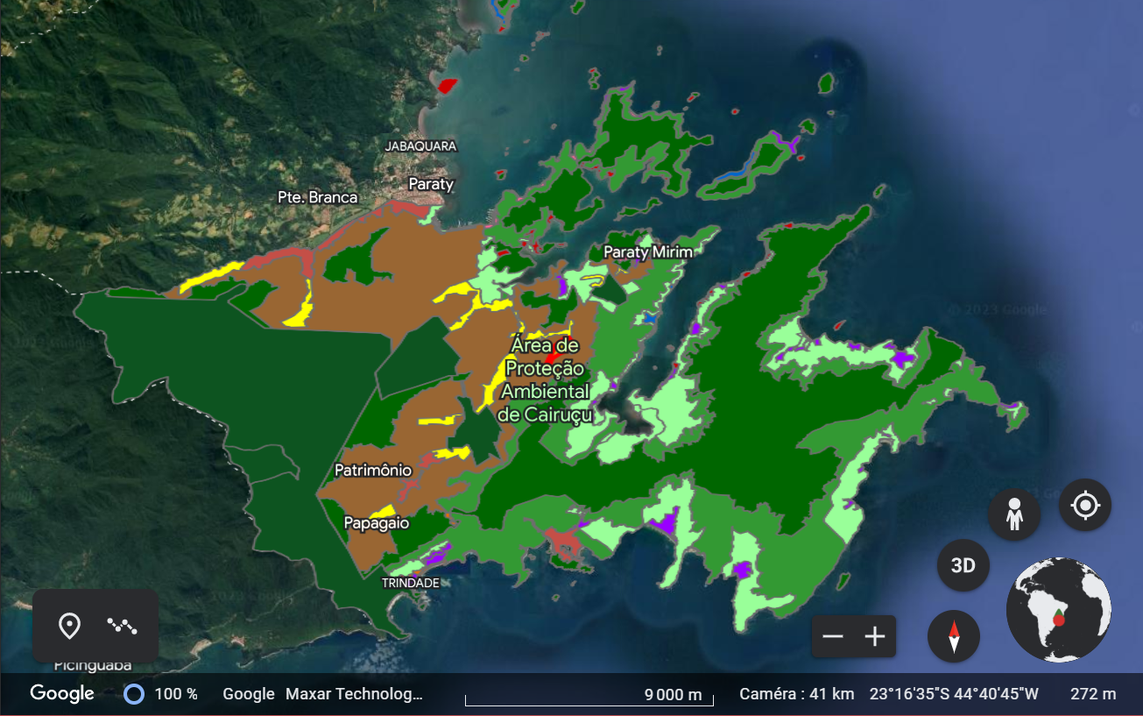

We are based in Paraty-Mirim.

**15 sec videos showing the regions**

**Our activities**

We made the bet to develop a sustainable economic model based on the management of natural resources and the development of traditional societies present in these places.

Our objective is to strengthen the local economies to undermine the impact of financial predation. Our actions are categorized into three different pillars which are:

* the implementation of socio-economic actions for sustainable development
* the preservation and regeneration of natural environments
* the development of land control strategies

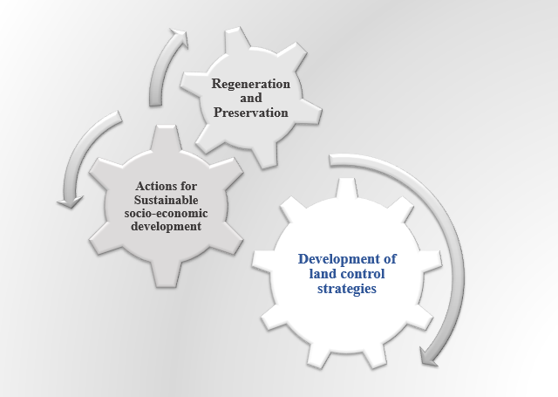

We believe in proposing a model oriented toward the regeneration and preservation of natural resources to ensure a durable balance of these areas and population in the face of present and future threats that could irrevocably alter these ecosystems. We fuel the sustainability of our approach on the extent of the area's cultural heritage and natural environment resources .

**The team:**

Felipe Alves Barreto- Lawyer

**Experienced lawyer practicing in the state of Rio de Janeiro.**

**Dedicated to the defense of deprived persons and the development of tailored solutions to support various communities.**

**Aficionado of Brazil Indigenous Art, and the development of traditional cultures**

Guilherme Cesar La Cava de Souza - Lawyer

**Experienced lawyer practicing in the state of Rio de Janeiro. Devoted to social rights and the defense of deprived communities.**

Guilherme de Moura Haguenauer PhD - Environmental Engineer

**Production Engineer with expertise in social impact assessments and sustainable development projects. Passionate about Regenerative Agriculture and Nature-based solutions and its potential to tackle the climate risks.**

Ekoé Michael Kangni-Foli PhD - Material Scientist

**Materials Scientist with expertise in the durability of construction materials.**

**Passionate about sciences and technologies and especially their potential to alleviate and remediate challenges faced by communities in diverse fields such as Agriculture and Healthcare.**

**2nd page: our offer**

**Facilitating land access in** units of preservation and sustainable use which include (**protected environmental areas) and orient land access towards:**

**- allowed locations and portions as per enforced laws**

**- portions sizes and locations which fit both purchasers’ purposes and conclusions of performed and documented environmental studies**

**- purchasers/ entities dedicated to nature preservation and regeneration or with established commitment for natural resources preservation.**

**Real estate pressure is a key aspect in environmental protection and the protection of traditional cultures. We are working to develop strategies to control the growing real estate and financial pressure. One of the components of this approach involves our actions aimed at both facilitating and controlling access to specific portions of land. This approach makes it possible to control the method of land use in order to ensure a match between the characteristics of the sites we propose and their uses. We ensure complete studies of the sites to which we facilitate the access and we ensure in the long term that the interactions linked to the human presence are in accordance with the site management plan and the recommendations of our experts (Lawyers, Environmental Engineers).**

**The development of regions with unique characteristics, the growing attraction manifested by the growing arrival of foreign funds are inevitable. Our approach takes this aspect into account by facilitating access to specific portions (sites chosen and studied, and various support services respective of purchaser needs from land acquisition to license obtention and construction project execution if necessary) guaranteeing legality, security and a match between a defined project and with the characteristics of the ecosystem in presence.**

**We offer portions of exceptional sizes at prices not aligned with the market. The acquisition of this land is accompanied by conditions aimed at preserving the environment and local cultures, in particular the non-divisibility of the portions sold below size allowed by regulation.**

**We also offer support for ecological constructions on lots for sale.**

**Locations**

|  |  |  |
| --- | --- | --- |
|  | The portions proposed are located 4 hours drive from Rio de Janeiro and 6 hours from Sao Paulo | |
|  | | The portions proposed are located 6 hours drive from Sao Paulo |

**________________________________________________**

**Characteristic of the site:**

